Objects:
Mixing Fermi-Amaldi functional with other exchange-correlation (XC) functionals to form a better XC function.

Introduction:
In Kohn-Sham DFT, exchange-correlation functional is the only unknown part.
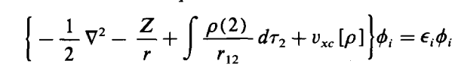
1

Existing exchange correlation (XC) approximations are divided into several categories, from local density approximation (LDA) to hybrid meta general gradient approximation (hybrid-mGGA). The first approximation was derived by Dirac to include the exchange interaction in the Thomas-Fermi model.

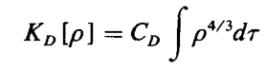
2

Shortly after, Fermi and Amaldi proposed a simple approximation to correct for the self-interaction, which is given by:
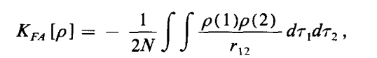
3
Equation 2 has been studied thoroughly and developed to high level functional approximations. However, Fermi-Amaldi functional does not get enough attention. Andres Cedillo, and coworkers proposed a Dirac-Fermi-Amaldi exchange (DFAX).

Pros and Cons about Fermi-Amaldi
Advantages
1. The Fermi-Amaldi model naturally satisfies the normalization condition.
2. The Fermi-Amaldi potential v has the correct asymptotic behavior −1/r.
3. The Fermi-Amaldi Approximation is exact for one-electron system. In other words, it is self interaction-free.

Limitations and Disadvantagess
1. For two systems, A and B, in the limit of infinite separation, we should have V_ee [ρ_A + ρ_B ] = V_ee [ρ_A ] + V_ee [ρ_B ]. But in FA approx., V_ee [ρ_A + ρ_B ] > V_ee [ρ_A ] + V_ee [ρ_B ]
2. For uniform electron gas systems, E_xc should recover LDA. But FA term does not show such property.
3. The scaling properties of FA term is the same with J[ρ], (J[λρ] = λ^2 J[ρ]) but differs from E_xc.

Implementations
We choose NWChem as the platform to implement FA model.

The general self-consistent-field procedure is shown below. NWChem follow these steps to solve the Kohn-Sham equation or the Hartree-Fock equation. ( from Mordern Quantum Chemistry p146)
1. specify a molecule (a set of nuclear coordinates {R_A}, atomic numbers {Z_A}, and number of electrons N) and a basis set {ϕ_μ}.
2. Calculate all required molecular integrals, S_ μv (Eq.3.136), H^{core}_{μv} (Eq.3.149) and ( μv | λσ ) (Eq. 3.155).
... Omit the regularization steps
3. Obtain a guess at the density matrix P (Eq. 3.145)
4. Calculate the Fock matrix based on P (Eq. 3.154)
5. Diagonalize the Fock matrix to abtain the new set of orbitals C
6. Build the new density matrix P from C
7. Determine whether the procedure has converged, i.e., compare the new P with the old one. If not converged, return to step3. Otherwise, the resultant solution, represented by C, P, F, etc., can be used to calculate other quantities of interest.

Our implementation focuses on the expression of Fock matrix.
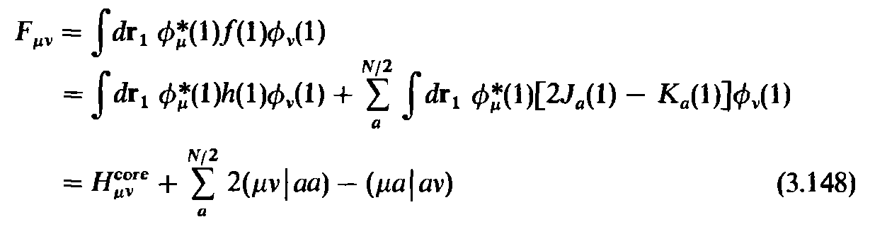

In NWChem, src/ddscf/fock_2e_lab.F actually computes the Fock matrix.
For restrict fock matrix see: subroutine fock_2e_rep_mod_2_label
For unrestrict fock matrix see: fock_2e_rep_mod_4_label
Below is a code map which points out all the important module (all module files end with .F) and subroutine:
src/nwdft/scf_dft/dft_scf.F(main scalar DFT driver)
|
--> dft_fockbld ==> build the fock matrix
|
-->xc_getv ==> calculate the HF exchange/Coulomb & DFT xc
|
--> fock_2e ==> calculate the coulomb parts
|
--> ao_fock_2e
|<---------------------------|
|
--> ao_replicated------------>|
| \
--> fock_2e_rep |-->fock_2e_rep_from_file(fock_2e_file.F)
(first) (later)
|<-------------| |
| |
-->fock_rep_txs(ao_replicated.F) -->int2e_file_rep_fock(int2e_file.F)
| |
*(fock_2e_lab.F)*-->fock_2e_rep_label -->fock_2e_rep_mod_label ---- >|
| |
-->fock_2e_rep_1_label(before build fock)** |
| |
-->fock_2e_rep_4_label(during building)** |
|
|<------------------------------------------------------------------------------|
|--> fock_2e_rep_mod_4_label****
k_a --> a2/N_a * j_a
k_b --> a2/N_b * j_b

f_a --> k_a
f_b --> k_b

K_a --> -(d_a,k_a) = -a2/N_a * J_a
K_b --> -(d_b,k_b) = -a2/N_b * J_b

if N_a == N_b == N/2:
k_a == k_b == -a2/(N/2) * j/2 = -a2/N * j
K_a = -(d_a,k_a) = -(d/2,k_a) = -a2/(2N) * J
K_b = -(d_b,k_b) = -(d/2,k_b) = -a2/(2N) * J
K = K_a+K_b = -a2/N * J

Method:
Unlike Andres Cedillo, we multiplied coefficients with both Fermi-Amaldi term and other XC functionals (LDA: slater+vwn_5, GGA: Becke88+LYP) to achieve a higher flexibility, which are determined through a fitting process. The training set covers three chemical properties (atomization energy, ionization energy and proton affinity) and nearly 200 atoms and molecules. We adopted the conventional linear-regression method and Bayesian Optimization method to do the fitting.

The linear-regression is fast but not a self-consistent fitting. However, Bayesian Optimization is slow and have a chance to find a better fitting.

Linear-regression procedure: see How_to_fit_the_Fermi_Amaldi_model.pdf
Bayesian optimization: see Bayesian Optimization.pdf

The result is listed in REFERENCE_ALL

For Jinlin

1. NWChem
Most of the info can be found in this webpage: https://nwchemgit.github.io/
If you encountered any technology problem or academic issue, you can post your question on: https://groups.google.com/g/nwchem-forum
There is also an achieved forum, which might have some valuable discussion: https://nwchemgit.github.io/oldforum.html

input sample:

start SiH2+
title 'SiH2+'
charge 1.0 # 1.0 mean 1 positive charge
geometry units angstrom
load SiH2+.xyz # coordinates are stored in xyz file
end
basis
* library 6-31G(2df,p) # this is the basis set you choose
end
dft
odft # key word for open shell (or unrestricted calculation)
mult 2 # you have to figure out the multiplicity, some molecules might have strange multiplicity
XC slater 1 vwn_5 1 # NWChem support a bunch of XC functional, you can easily scale each # component by adding a parameter behind the key word, the detailed info can be #found at https://nwchemgit.github.io/, under section Quantum Mechanical
# Methods, then Density Functional Theory (DFT)
decomp # Keyword for energy details, with decomp, output file will list out all energy
# components, its very useful!!
maxiter 199 # Keyword for the maximum scf iterations. Some molecule does not converge
# easily or within the default iteration numbers.
end
task dft energy
task dft freq numerical # you must use freq numerical to calculate the Zero-point energy after
# implementing the FA model. Normal freq task does not supply our
# implementation

Compilation tips:
Every time you make some small changes to the source code, you don’t have to compile the whole NWChem again. Just find the folder contain the files changed, type “make”, then type “make link”. This will save you huge time, especially on server. When you compile NWChem on server (cedar.computecanada.ca), you have to specify the compiler to be ifort, like “make FC=ifort” and “make link FC=ifort”.

For the first compilation on server, you need to download the zip file from https://launchpad.net/ubuntu/+source/nwchem
then enter the src folder, using the following setup and command

export NWCHEM_TARGET=LINUX64
export NWCHEM_MODULES=all
export USE_INTERNALBLAS=y
export USE_MPI=y
make FC=ifort

If it does not work, you can contact support@computecanada.ca for help

Python Script info:
I will go through this part with you face to face (my code is lazy, it’s not organized very well). Once you have some clues about how it works, you can make yourself a better version.

About server: ssh username@cedar.computecanada.ca

You need to compile a personal version of NWChem, and place it anywhere you like. But when you submit jobs, you must submit from ~/scratch. For example, I made some folder sunder /home/ysy1111/scratch and stored my input files in these folders.

In order to submit all atoms and molecule in the same time, you need to make a sh file, here is an example,

#!/bin/bash
#SBATCH --mem-per-cpu=2G # memory, roughly 2 times %mem defined in the input name.com file
#SBATCH --job-name=Al
#SBATCH --time=0-03:00 # time (DD-HH:MM)
#SBATCH --account=def-yawang
#SBATCH --ntasks=4 # number of MPI processes
module load StdEnv/2020 # you might not need this line, the admin team just upgrade the server to # the newest version.
mpirun /home/ysy1111/nwchem-7.0.2-release/bin/LINUX64/nwchem Al.nw > Al.out 2>Al.log

To submit the job, type “sbatch xxx.sh”

Also the default version of server might not contain the library used in your python script. What you need to do is load them first, the most common two loadings for me are:
“module load python/3.7” # these is not necessary, as long as your script works well with the newest # python
“module load scipy-stack” # this one contains many important libraries, like Numpy, Pandas.
You can find useful info at https://docs.computecanada.ca/wiki/Python

After you submit the job, you can check the job state by typing “sq”

Useful command line:
grep "the info you want" filename
---- example:
grep "Total DFT" Al.out, grep "Zero-Point" Al.out, help you to locate the total energy and zpe in output files

